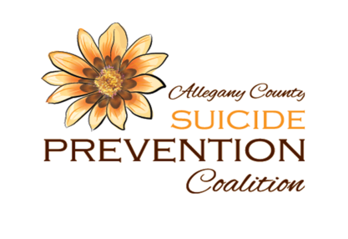
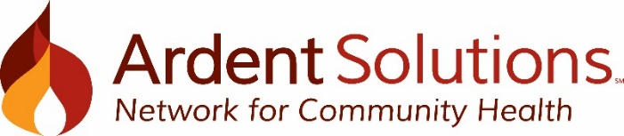

Allegany County Suicide Prevention Coalition: Bi-Monthly Meeting Minutes

Date: Thursday, March 11, 2021 Location: Zoom Time: 2:30 – 3:30pm
Mission: We are committed to embracing life by being a resource for suicide prevention, intervention and postvention
Vision: All people know they are valued and therefore are empowered to live.
Core Belief: We believe all people have inherent value, deserve respect, and have purpose.
- New Business
- Guest Speaker – Danielle DeLong, Age-Friendly Allegany County Community Assessment Survey
  - Overview of Age-Friendly Communities & Age-Friendly Allegany County Initiative
  - 2020 Community Outreach Projects: November “Signs” of Support, December Operation Holiday Cheer
  - Age-Friendly community assessment is live and nearly 150 responses have been collected. Survey responses will be collected until May 31, 2021 through survey monkey or via paper surveys. For more information, contact Danielle DeLong at ddelong@ardentnetwork.org
- 2021 Meeting Schedule
  - May 6, July 1, September 2, November 4 from 2:30 – 3:30pm. Meetings will be virtual for the foreseeable future
- Overview of the Surgeon General’s Call to Action to implement the national strategy for suicide prevention
  - 4 Strategic Directions
    - Healthy and Empowered Individuals, Families and Communities
      - Activate a broad-based public health response to suicide
      - Address upstream factors that impact suicide
    - Clinical and Community Preventive Services
      - Ensure lethal means safety
    - Treatment and Support Services
      - Support and adoption of evidence-based care for suicide risk
      - Enhance crisis care and care transitions
    - Surveillance, Research and Evaluation
      - Improve the quality, timeliness, and use of suicide-related data
  - I encourage you to review the slide deck and meeting recording for more information on each strategic direction and action.
- Updates
  - Messaging and Awareness
    - Newsletter should be out by the end of March 2021
    - Push to recruit more active members and members from other sectors such as the faith-based community and local colleges.
    - May is Mental Health Month, National Prevention Week is May 9 – May 15, 2021 (substance use and mental disorders)
    - September: National Suicide Prevention Month & Week. Exploring a return to in-person walk and awareness event
  - Programs and Events
    - Youth Mental Health First Aid Trainings scheduled for April 16th and May 15th
    - Seeking recommendations for target audiences for Talk Saves Lives, 1 hour presentation
    - Exploring ASK workshop – suicide prevention program for children
    - ASIST and SafeTalk remain unavailable since they can’t occur virtually
  - Suicide Response and Postvention
    - Reviewing surveillance data
    - Exploring bereavement support groups and community support groups
    - Updating Postvention packets
      - conversion to electronic forms, review content of packets, check with AFSP and update locations with postvention packets
- Round table reports
  - A. Weaver noted March is Problem Gambling Month and March 22-28 is National Drug and Alcohol Facts Week. Ann will share materials to include with the minutes. Additionally, April is National Alcohol Awareness Month.

- Next Coalition Meeting
Date: May 6, 2021
Time: 2:30 – 3:30pm
Location: Zoom

